# 

EDITION OLD CITY HOTEL SUSTAINABILITY

REPORT 2023

one

# Machine Translated by Google

CONTENTS

* About the report / Scope
* Facility introduction and facility features
* Sustainability team
* Sustainable management system
* Sustainable management system practices
  + Legal compliance
  + Stakeholders and communication
  + Customer experience
  + Staff participation
  + Accessibility
  + Personnel and working life
  + Fair pricing
  + Education and career management
  + Employee and human rights
  + Local employment
  + Social studies in staff
  + Increasing environmental impacts and nature protection activities
  + Buy
  + Local purchasing
  + Environmentally friendly purchasing
  + Efficient purchasing
  + Energy management – Energy saving
  + Water management and wastewater
  + Food waste and solid waste
* Studies to support cultural heritage • Sustainable management system policies
  + Quality policy
  + Cultural sustainability policy
  + Occupational health and safety policy
  + Environmental protection and waste management policy
  + Child rights exploitation and abuse policy
  + Energy efficiency policy
  + Human resources policy
  + Women's rights and gender equality policy
  + Social responsibility policy
* Studies planned to be realized within the scope of sustainability

-

-

2

# Machine Translated by Google

ABOUT THE REPORT / SCOPE

Our hotel undertakes to fulfill the obligations of the Turkey Sustainable Tourism Program regarding sustainability and to continuously improve its sustainable management system in order to increase its sustainability performance. Due to the situation of the sector, environmental, social, technological, economic and cultural risks, changes and updates stemming from the legislation, our management system is constantly reviewed, and if necessary, the system and policies are updated.

Our “sustainability policies” are our company's commitment to this issue. From this point of view, all our orientations will be in this intention and direction. Our aim is to transform the sustainability principle into a "business manner" in the basic areas of our hotel and to bring it into the corporate memory. Turning our efforts into success and gaining continuity will only be possible if we act together with our employees, guests, business partners, suppliers, solution partners, and all our interlocutors in our immediate environment and make them a partnership that we will strengthen day by day. It is very valuable to raise the awareness of the personnel, who are considered as an integral part of the sustainability approach, to provide opportunities for them to be involved in the process and to contribute to development opportunities. In this context, in our annual training plans and orientations; Social

rights, supporting local employment, protecting natural life, supporting wildlife, historical touristic places of the immediate environment, cultural richness, ecological diversity, energy and water saving, environmental activities-recycling system, orientation to local resources, etc. Efforts are made to disseminate the sustainability philosophy. The main objective is to provide strategic support to

all companies and departments for the improvement of business results through human resources management in line with business strategies, and to contribute to creating value for all stakeholders by creating and promoting a high performance culture. In addition to all these, it is aimed to increase awareness in every sense with orientation training and professional level trainings determined according to annual training needs.

Sustainability studies are under the coordination of Hotel Management, and the evaluation of our activities and performance in this field is always open to the expectations and opinions of our stakeholders.

3

# Machine Translated by Google

FACILITY DESCRIPTION AND FACILITY FEATURES

## Our facility is located in Istiklal street no 182 Beyoÿlu -Istanbul.

In our rooms, which have the necessary facilities for our guests to feel comfort and peace;

High speed wireless internet

TV/Satellite

## Mini bar

Guest water and beverage tray

Message notification service

## Turn Down Service Pillow quilt menu

wake up service

Bellboy Service

Laundry, dry cleaning, tailor, ironing service

Hair dryer

bathroom hygiene kit

## Private jacuzzi room options

Smoke detector linked to the central fire system

There is a special insulated door and window system for noise.

In addition to our rooms, the breakfast room - patisserie, guest rest area specially designed for our guests available.

For the access of our disabled guests, there is 1 special room and 1 disabled toilet in the common area. Facility entrance, elevator, rest area, unhindered access to the patisserie are available.

4

Machine Translated by Google

SUSTAINABILITY MODE

Sustainability team in our facility

Sustainable management system ensures that certain policies are implemented by all employees in the fields of quality, economy, management, environment, culture, human rights, health and safety, targets are set and the business management processes are continuously improved by monitoring whether the targets are achieved or not.

If the determined targets are achieved, new targets are determined. If they are not achieved, our targets, policies and practices are reviewed. In this way, we strive to ensure continuous improvement.

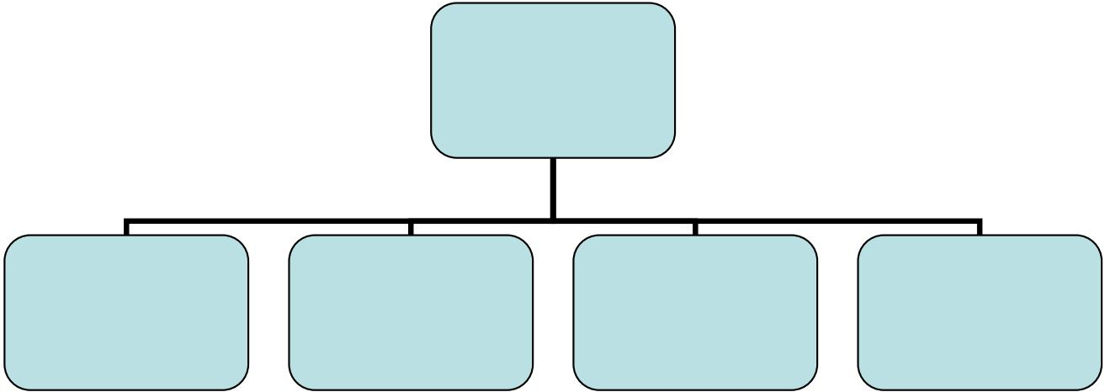

**Team Leader**

**OSMAN DURU TUGBA YUCEKAYA**

Environmental Representative

Energy Management

Representative

Employee Representative

Employee Support

element

TUGBA YUCEKAYA FATIH GULUR

Technical Affairs manager

SERKAN AYAS

5

# Machine Translated by Google

SUSTAINABLE MANAGEMENT SYSTEM

The basis of our sustainable management system is based on risk analysis. Risk analysis is carried out under the headings of environment, natural disasters, society, culture, economy, quality, human rights, health and safety. New titles can be added if necessary.

A crisis management system that determines what to do in case the risks occur after the risks are analyzed.

We also have a policy and system. The appendix of this document includes how to do risk analysis and crisis management.

The SYS includes the implementation of certain policies by all employees in the fields of quality, economy, management, environment, culture, human rights, health and safety, the setting of targets and the continuous improvement of business management processes by monitoring whether the targets are achieved or not.

If the determined targets are achieved, new targets are determined. If not achieved, our goals, policies and practices are reviewed. In this way, we strive to ensure continuous improvement.

The targets of our hotel's management system and the performance indicators that monitor compliance with the targets are included in the annex of this document.

Our hotel undertakes to fulfill the third stage obligations of the Turkey Sustainable Tourism Program regarding sustainability and to continuously improve its sustainable management system in order to increase its sustainability performance.

Due to the situation of the sector, environmental, social, technological, economic and cultural risks, changes and updates stemming from the legislation, our management system is constantly reviewed, and if necessary, the system and policies are updated.

The above-mentioned steps can be summarized as the Plan-Do-Check-Act (PUKÖ) approach.

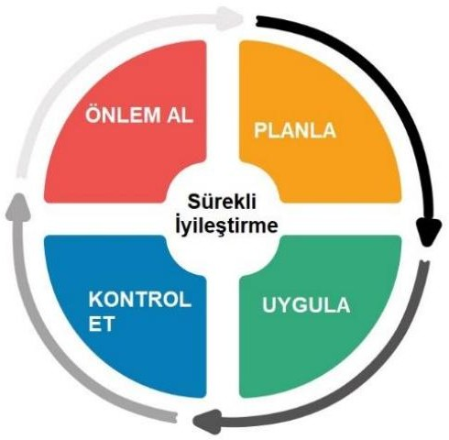

Figure 1. PUKÖ Cycle

## 6

Machine Translated by Google

*Plan:* Our hotel attaches importance to the environment, society, culture, national economy and management system and sets goals. It plans the roadmap and actions to be followed in order to achieve the determined goals.

*Apply:* Our hotel determines its basic policies and practices regarding environmental, cultural, social, human rights, health and safety. It monitors, measures and records them at intervals defined by the relevant personnel.

*Check:* Feedback from both staff and customers is tracked and recorded at our hotel. Corrective measures are taken if necessary.

*Take action:* This is the step in which our hotel takes action to correct the problems identified in the check step. Corrective measures and actions are recorded and archived.

SUSTAINABLE MANAGEMENT SYSTEM APPLICATIONS

LEGAL COMPLIANCE

## Our hotel undertakes to comply with the applicable laws, regulations and international agreements, maintains an up-to-date list of these, regularly informs its personnel about these, and provides the necessary training to the personnel.

Our hotel presents all necessary permits, certificates and documents to the relevant persons and institutions, if asked or requested to submit it.

These documents, Business Opening and Working License, last month's personnel insurance statement, tax plate, emergency action plan, personnel trainings and certificates, contract with the workplace doctor, sewer connection certificate obtained from the municipality, documents regarding pest control and other necessary documents. are documents.

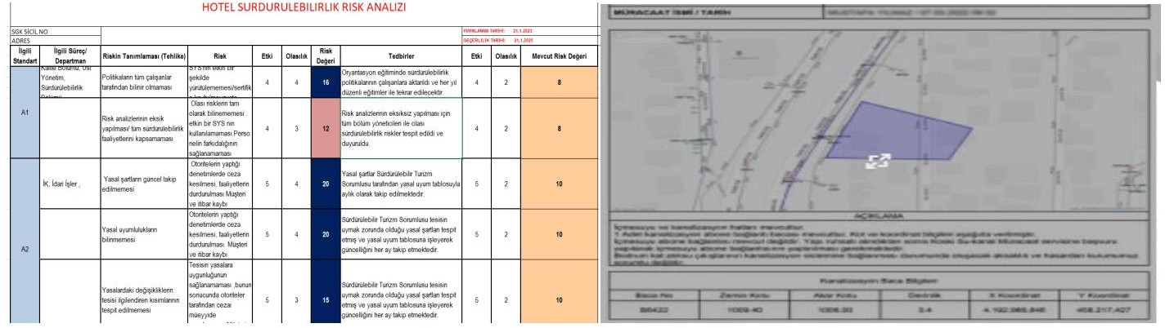

STAKEHOLDERS AND COMMUNICATION

## Our hotel gives accurate information to all segments of the promotion. Always uses real visual material in promotion. Our hotel has a transparent and realistic structure in terms of its products and services on its website, social media accounts and other printed and written promotion channels and marketing communications.

Our hotel also shares its actions and transactions regarding policy and sustainability with its employees and customers in an open and transparent manner. To do this, our hotel's website is used.

7

# Machine Translated by Google

Periodic reports on sustainability performance are published on our website. These reports are prepared in appropriate periods.

Our hotel has a system that aims to receive feedback from our customers, public institutions, municipalities, employees, local people and all other relevant persons and institutions regarding our sustainability performance, policies and practices. Through this system, we receive feedback from both our staff and customers.

Our system is designed to enable and encourage our customers and staff to provide feedback quickly, simply and effectively.

This system includes survey applications for guests, regular monitoring of social media accounts, e-mail, messaging services and other communication channels for employees, and e-mail communication for all other stakeholders and their regular follow-up.

CUSTOMER EXPERIENCE

Our hotel attaches great importance to customer satisfaction. Customer satisfaction includes feedback from the system described above regarding sustainability. The results obtained are analyzed. negative feedback and

responses are recorded and necessary precautions are taken.

STAFF PARTICIPATION

The most important element of our hotel's management system is our employees.

Our employees know what to do in our management system and our sustainability policies and practices. What our employees should do is defined in writing, communicated to them, and necessary training and guidance are provided regularly. Trainings on this subject are recorded.

Our employees take an active role in the development and continuous improvement of our management system and sustainability performance. We review and improve our system in line with the feedback from our employees.

Including orientation trainings in line with our sustainability policies and management system; employees are provided with periodic training programs related to sustainability and working areas, on-the-job trainings, trainings required in accordance with legal regulations, and guidance support. Occupational Health and Safety trainings, Kitchen/service/massage etc. hygiene trainings for personnel, water and energy saving, chemical substance use rules, fire protection, first aid, etc. We implement annual training plans on

Our employees have free and open access to all our training materials.

Our hotel undertakes to comply with the relevant provisions of the Labor Law No. 4857 and gives at least minimum wage to the employee. In addition, our hotel undertakes to comply with the Social Insurance and General Health Insurance Law No. 5510 and the Occupational Health and Safety Law No. 6331. Our hotel has formed a “Sustainability Team” to manage its sustainability activities.

## 8

Machine Translated by Google

ACCESSIBILITY

Our hotel is committed to providing accessible tourism services for everyone within its means and clearly and accurately informs its customers and stakeholders about the level of accessibility through its website.

Our hotel is also committed to full compliance with the legal regulations regarding accessibility and to continuous improvement in this regard.

STAFF AND WORKING LIFE FAIR REMUNERATION

* The wages, working conditions, working hours that our employees will receive before they start working at our facilities, They are informed on issues such as when they will receive their wages.

EDUCATION AND CAREER MANAGEMENT

* All of our employees can benefit from the right to education equally. In addition to the legal and vocational training required by the hotel industry, orientation trainings are included in line with our sustainability policies and management system; employees are provided with periodic training programs related to sustainability and working areas, on-the-job trainings, trainings required in accordance with legal regulations, and guidance support. Occupational Health and Safety trainings, Kitchen/service/massage etc. hygiene trainings for personnel, water and energy saving, chemical substance use rules, fire protection, first aid, exploitation and harassment, cultural heritage sites and codes of conduct, etc. We implement annual training plans on
* Our employees have free and open access to all our training materials.
* 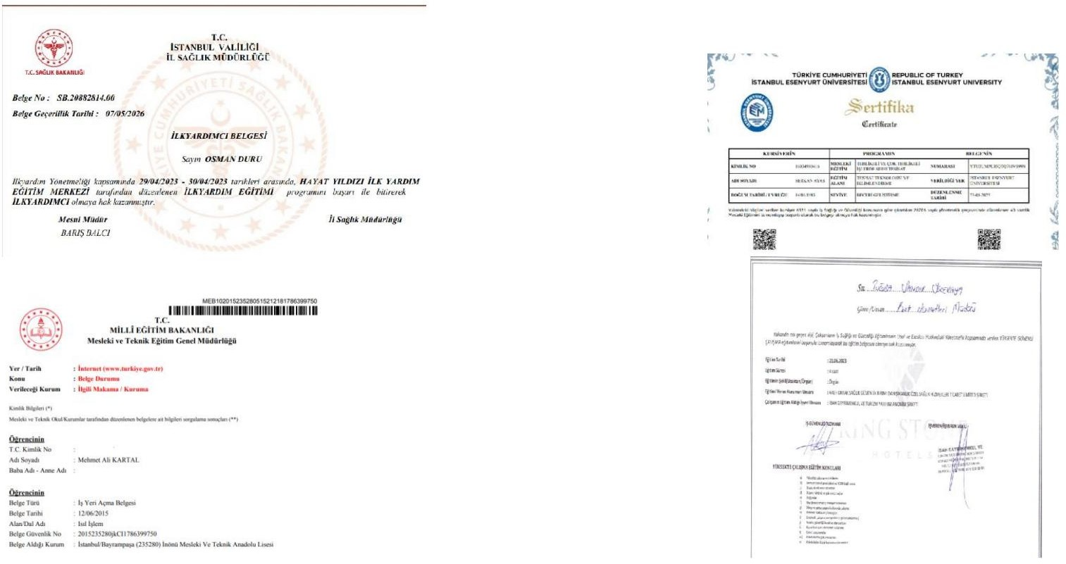Personnel tracking system and promotion management of personnel in career management according to determined criteria. is done.

## 9

Machine Translated by Google

EMPLOYEE AND HUMAN RIGHTS

* Our hotel undertakes to comply with the relevant provisions of the Labor Law No. 4857 and pays the employee at least minimum wage. Our hotel also undertakes to comply with the Social Insurance and General Health Insurance Law No. 5510 and the Occupational Health and Safety Law No. 6331.
* Ensuring absolute satisfaction of the employees is a matter of priority. With this point of view, including the legal rights of the employee, and some benefits provided by our business as fringe benefits; It is the management's responsibility to ensure the working environment, psychology, self-motivation, performance, in short, all the comfort in the workplace. • Although we have a number of foreign employees in our hotels, as

a business that caters to guests from different nationalities and provides services at an international level, nationality, race, language, etc. for our guest or guests. It is against both our hotel management and working principles to discriminate. Therefore, all personnel transactions of our employees from different countries or nationalities are followed in accordance with legal procedures, and equal opportunities are offered to all our employees, regardless of their characteristics, within the hotel.

LOCAL EMPLOYMENT

In our organization, there is a performance system based primarily on local employment. Priority in recruitment is made from local people. Our local employment rate in 2023 is 99%.

SOCIAL WORK WITH STAFF

In-house activities to increase the motivation of all our employees and to keep the team spirit alive: Distributing gifts and souvenirs on special days

no birthday celebration

Donating trees to the theme on staff birthdays to offset greenhouse gas and carbon emissions. Giving importance to the timely payment of salaries and employee progress payments,

The practice of giving gifts to employees who get married and have children,

Free museum cards are given to employees for cooperation and contribution to local administrations and support for cultural heritage. In case the relatives of our staff request, a family-friend discount is applied.

Work-uniforms of all employees and all work-related clothes are washed by the hotel's contracted laundry and the cost is covered by the hotel.

Participatory social responsibility projects.

Periodic health screenings are carried out regularly.

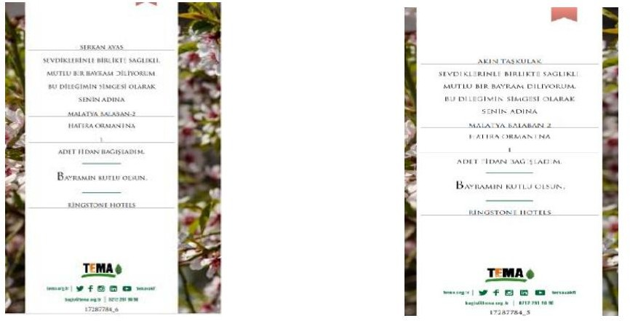

# 10

Machine Translated by Google

REDUCING ENVIRONMENTAL IMPACTS AND NATURE CONSERVATION ACTIVITIES

Being aware of the fact that the natural resources we use, the immediate environment and region we interact with, and the great family we have formed with our employees have a great impact on our corporate success and the experiences we give to our guests, we adopt a management approach to review our responsibilities at every stage. In this direction, we have created an "Environmental Policy" for the protection and continuity of the environment we live in, and we aim to improve our current situation day by day by planning our business processes accordingly and analyzing the results. To achieve this goal;

Complies with applicable environmental laws, regulations, legislation and regulations and fulfills all requirements; We carry out our activities by constantly improving ourselves and ourselves.

It is of great importance for us to protect the environment, to deliver it to future generations in a clean and healthy way and to contribute to the preservation of the ecological balance.

Our work in order to comply with the current International and National legal regulations and requirements, to minimize the pollution that may arise as a result of our activities, and to use natural resources correctly; to share with our employees, guests, suppliers and the community; It is our priority to set targets for continuous improvement, to carry out the necessary research, project design and implementation on the principles of protecting biodiversity and the efficient use of energy cycle.

In order to minimize carbon emissions, we have published the Istanbul public transportation maps on our website, and our staff and guests donate trees to environmental organizations, themes and foundations in certain periods.

In the agreements we have made with the tour company and our suppliers, we have primarily been informed about the use of electric vehicles and vehicles.

Environmental impact assessment analysis and carbon emission measurement analysis are updated regularly. We determine the impacts we make on the environment and take them under control.

Believing in the continuity of education, we ensure that environmental awareness is adopted not only by our employees but also by our guests, and we contribute to environmental protection projects by cooperating with local governments.

By preventing environmental pollution, it is one of our goals to recycle the waste in question to a large extent. We are prepared for the risks related to pollution for emergencies (fire, explosion, flood, earthquake, leakage, etc.) and

We comply with legal regulations.

We strive to minimize our waste, prevent pollution at its source, use energy efficiently and reduce the impact of our activities on the environment.

We continuously improve our environmental performance in waste sorting and reducing the amount of waste, efficient use of natural resources.

We use energy and water saving systems in our hotel

11th

# Machine Translated by Google

BUY

Our purchasing policy includes policies for local, environmentally friendly, fair trade and efficient purchasing.

Our hotel monitors our goods and services resources. We hold regular meetings with our suppliers. We check their sustainability certificates, information and documents.

LOCAL PURCHASE

Our hotel gives priority to local suppliers when purchasing goods and services, provided that they are of good quality and reasonably priced. For this reason, it regularly audits its suppliers, updates the supplier list and informs its suppliers. The ratio of goods and services received from the people of the region is measured.

While purchasing goods and services, our hotel also gives priority to fair trade suppliers for imported products, provided that they are of good quality and reasonably priced.

ENVIRONMENTALLY RESPONSIBLE PURCHASING

## Our hotel follows an environmentally friendly policy in purchasing, giving importance to efficient purchasing, energy saving and water saving in order to reduce food and solid waste.

Our hotel gives priority to environmentally friendly products (products with environmental labels) in its purchases. If there are no environmentally labeled products in the product group to be purchased, it selects the relevant products, production and all other processes from suppliers and manufacturers that do not harm the environment.

## In this context, our hotel prioritizes the selection of suppliers with sustainability certificates while making its purchases. Sample certificates that can be sought from suppliers are ISO14001, ISO50001, ISO14064, ISO20400. Environmentally certified (FSC, MSC, AB-EcoLabel, etc.) or traceable products are preferred for wood, fish, paper and other foods.

Threatened species and species that are forbidden to be sold (fish, trees, plants, game animals, etc.) are not taken or used in our hotel.

The ratio of our purchases from environmentally certified, local producers and suppliers and fair trade suppliers to total purchases is measured.

Our hotel has targets for environmentally certified, local and fair trade procurement. In this context, we aim and pay attention to increase the ratio and number of local and fair trade suppliers in our purchases.

EFFICIENT PURCHASING

## Our purchasing policy favors reusable, returnable and recycled goods.

Our hotel also gives priority to bulk purchase and bulk product purchase. In this way, fewer shipments are made to our hotel and less greenhouse gas emissions are produced.

The absence of unnecessary and excessive plastic, nylon, paper, glass, wooden packaging in the products arriving at our hotel is our main priority and preference.

# 12

Machine Translated by Google

Disposable products and unnecessary packaging (especially plastic) are avoided in the purchase of consumables and amenities. The purchase and use of consumables and disposables is monitored and managed.

ENERGY MANAGEMENT

ENERGY-SAVING

Our hotel has an energy saving policy. The policy includes regular measurement, monitoring and reduction of energy consumption.

Our hotel groups its energy consumption according to energy type, and the energy consumption of different units is monitored.

The total energy used in our hotel is measured by type.

Our hotel identifies activities with high energy consumption, plans and implements corrective measures to reduce energy consumption in these areas and activities (heat insulation systems, preference of devices with low consumption among energy consumption class devices, use of led bulbs instead of high energy consumption lighting such as incandescent, etc.) . In addition, our hotel uses energy- saving equipment.

Our hotel informs and trains its employees and stakeholders on energy saving.

Environmental elements realized within the scope of Sustainability in our hotel

* + Digital recording system for supplier, purchasing and office work to minimize paper consumption

has been initiated.

* + E-invoice was introduced in accounting for invoicing transactions.
  + Packaging Wastes are collected and delivered to the local administration in a controlled manner.
  + To minimize the use of electricity, water and energy resources used in common areas. awareness activities have been carried out.
  + Paretor application has been made on the faucets used in all rooms and areas, and the water flow adjustments have been adjusted to fill a 1 liter container in 12 seconds.
  + All air conditioning system degrees are set to 18-23 degrees.
  + The use of ecolabel products is prioritized by suppliers. • Local and closest suppliers are pioneered in order to reduce carbon emissions.

WATER MANAGEMENT AND WASTEWATER

Our hotel has a water saving policy. Our policy includes regular measurement, monitoring and reduction of water consumption.

The water risk situation in the region where our hotel is located has been determined. For this, the Water Risk Atlas prepared by the World Resources Institute is used. The link to the relevant [website](https://www.wri.org/applications/aqueduct/water-risk-atlas/%23/?advanced=false&basemap=hydro&indicator=w_awr_def_tot_cat&lat=39.031986028740086&lng=30.190429687500004&mapMode=view&month=1&opacity=0.5&ponderation=DEF&predefined=false&projection=absolute&scenario=optimistic&scope=baseline&threshold&timeScale=annual&ye) is located here.

In the risk analysis, the water risk was also evaluated and a water management plan was made. This plan includes targets and reports for measuring and monitoring water use and reducing water consumption.

Due to the water use activities of our hotel, the creatures living in waters such as sea and lake are not harmed. Nevertheless, the possibility of harming these creatures has been evaluated in the risk analysis and necessary precautions have been taken.

## 13

Machine Translated by Google

Our hotel complies with all legal requirements and regulations in the use of water.

The water comes from a legal and sustainable source.

We measure our water consumption. The total water used per guest or overnight is calculated and reported. The file attached to this document is used for measurement.

We have targets to reduce water consumption. To this end, our hotel plans and implements corrective measures. Water-saving equipment is used in our hotel. Our hotel uses good practices such as changing sheets and towels upon guest request.

Our hotel informs and guides its employees and stakeholders about water saving. Our hotel mobilizes all its resources so that its waste water does not harm the environment.

The regulations determined by the local government are followed for the disposal of waste water. Legal requirements are complied with in this regard.

FOOD WASTE AND SOLID WASTE

Our hotel has a Solid Waste Management Plan. The plan includes regular measurement and monitoring of waste generation, waste reduction, reuse, recycling and waste disposal.

Solid wastes are separated according to their types such as food, recyclable, toxic/hazardous and organic, while recycling and reuse conditions are taken into consideration.

Our hotel informs and guides its employees and stakeholders on waste management regularly with various visual and communication materials.

Solid wastes separated according to their types in our hotel are collected by authorized and licensed companies.

Solid waste, including food waste, is measured by type. In our hotel, the amount of solid waste per guest or overnight is calculated and reported.

Our hotel has also identified activities and risk areas where solid waste generation is high. It plans and implements corrective measures to reduce food waste and waste. It is aimed that solid waste disposal will not have a negative impact on the local population or the environment. Compliance with the "Zero Waste Regulation" related to solid waste management is ensured.

# 14

Machine Translated by Google

WORKS TO SUPPORT CULTURAL HERITAGE

In our facility, a cultural heritage list has been published on the website related to supporting cultural heritage and codes of conduct have been published in places subject to cultural heritage in these areas. Trainings were given to all employees regarding the studies created and these studies were published in all areas with the QR code system.

We are aware of our duty to protect local culture and values. In this context;

Cultural promotion

## Contributing to the trade volume of the region Promotion of natural and historical riches

Launch of appropriate code of conduct in local areas Protection of historical and cultural assets

We have a high level of sensitivity in carrying out studies on the Employment of Indigenous People and being involved in activities.

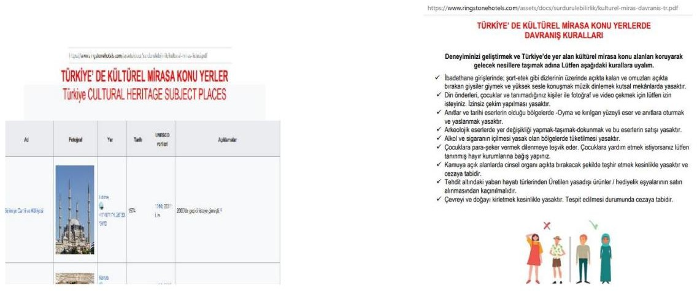

15

Machine Translated by Google

SUSTAINABLE MANAGEMENT SYSTEM POLICIES

ÿ QUALITY POLICY

On the way to reach our vision;

* + To welcome guests at the highest level and to be a leading company in the sector,
  + Establishing our founding philosophy with all our personnel, we ensure continuous improvement, trust in the workplace and our guests' satisfaction.

to provide service that exceeds expectations,

## Compliant with national and international legislation and conditions; With a preventive approach to food safety risks,

to serve with sensitivity,

* + To be an exemplary business for all other organizations in our country and to create value,
  + To ensure the health, life and work safety of our guests and staff.

To prevent these accidents by minimizing all risks that may endanger them,

* + To make the quality measurable, to ensure the continuous improvement of the system and to set targets and

to ensure the unity of our employees and management,

* + To create environmental awareness together with the hotel management and our staff, to create a cleaner environment for future generations,

## Leaving a healthy and safe environment is among our priority quality targets.

16

Machine Translated by Google

ÿ CULTURAL SUSTAINABILITY POLICY

Presenting cultural heritage: Our hotel respects the intellectual property rights of local people. Authentic elements of traditional and contemporary local culture are evaluated in our cuisine, design and decoration.

Artifacts: Our hotel does not buy, sell, trade or display historical and archaeological artifacts.

Promotion of sustainable local gastronomy: Our hotel gives priority to the promotion and consumption of local products. In all its activities, it will put forward innovative and creative practices to ensure sustainability in gastronomy.

17

Machine Translated by Google

ÿ OCCUPATIONAL HEALTH AND WORKER SAFETY POLICY

In order to protect our workplace, employees, guests and suppliers, to create a safe work environment and to ensure continuity;

* + We comply with all legal and other obligations regarding Occupational Health and Safety.
  + The principle that Occupational Health and Safety and improvement activities are the common responsibility of all employees.

we adopt.

* + We set targets for participation at all levels in Risk Assessment and Risk Reduction activities.
  + To achieve the sustainable goal of “Zero Occupational Accident” by continuously improving our Occupational Health and Safety culture. we aim.
  + We collaborate with all our employees in order to be a pioneer and an example for our work within the scope of occupational health and safety.

and share it with our environment.

# 18

Machine Translated by Google

ÿ ENVIRONMENTAL PROTECTION AND WASTE MANAGEMENT POLICY

It protects the environment in our business, prevents its pollution, by reducing our negative effects on the environment.

We care about protection.

For this;

* + We comply with legal regulations and try to reduce our environmental impact.
  + Take care to effectively separate our wastes according to their source, groups and hazard classes.

we show.

* + Hazardous substances and chemicals only when needed and as needed.

We know that its use will reduce both the negative effects on the environment and the amount of waste,

* + We prefer those with “recycling” and “environmentally friendly” labels in the materials we buy in our business.

We contribute to the protection of nature. We try to create opportunities for reuse,

* + Using disposable materials such as paper, napkins, toilet paper, packaging as needed

we take care to leave less waste to nature,

* + Stores waste correctly in separate areas according to their characteristics, meets legal storage time limits.

We keep their records by delivering them to licensed/authorized companies without exceeding

* + We try to use water, energy and all natural resources economically. This is our sensitivity.

We share it with our employees, guests and suppliers. on environmental management

we measure our performance, monitor this data with targets and try to improve our performance.

* + We aim to train our employees about the environment and increase their sensitivity.
  + Takes the necessary measures to protect the biodiversity in the environment. We comply with all legal requirements.

# 19

Machine Translated by Google

ÿ EXPLOITATION AND HARASSMENT OF CHILDREN'S RIGHTS POLICY

# Children are the relics of the future to us. Recognizing them as individuals, respecting their rights, all kinds of psychological, physical, commercial, etc. It is our primary responsibility to watch over and protect against exploitation.

To ensure this;

* + We do not allow child labor in our own institutions and also from all our business partners.

We expect the same sensitivity.

# Environments/opportunities within the enterprise that contribute to the development of children, where they can freely express their thoughts, wishes and feelings, and where they feel free and comfortable.

we present.

# We train our employees on the prevention and recognition of child abuse.

* + We make sure that children are under adult supervision in the activities they participate in.
  + Organizes training to raise awareness on the protection of children's rights and We support projects.
  + When we witness suspicious activities related to children, we first inform the hotel management and ask for help from official institutions when necessary.

## 20

Machine Translated by Google

ÿ ENERGY EFFICIENCY POLICY

In order to protect our world from possible dangers, we use our energy efficiently and set targets to reduce our energy consumption.

For this

* + We follow national and international standards, laws and regulations in order to fulfill both our responsibilities towards nature and our legal obligations, we voluntarily carry out studies to reduce energy use and/or continuously improve our energy consumption performance, and we monitor the results of our studies.
  + We set targets and use energy in our training programs in order to ensure the participation of our employees. we focus on efficiency.
  + We care about cooperating with all our stakeholders to create common goals and results in energy management. We try to maintain our interaction with our guests, employees, visitors and all business partners in order to reach a level of awareness and consciousness on these issues.
  + Researching, finding and purchasing energy efficient suitable product, equipment, equipment and technology alternatives.

## We try to buy and use.

* + Documenting our Energy Management System, disseminating it to all our departments, when necessary We aim to update, review and continuously improve.
  + Evaluates energy risks or emergencies such as energy restrictions,

We plan the measures that can be taken.

## Take care to effectively separate our wastes according to their source, groups and hazard classes. we show.

* + We know that using dangerous substances and chemicals only when needed and as needed will reduce both the negative effects on the environment and the amount of waste,
  + We prefer those with “recycling” and “environmentally friendly” labels in the materials we buy in our business. We contribute to the protection of nature. We try to create opportunities for reuse,
  + We take care to leave less waste to nature by using disposable materials such as paper, napkins, toilet paper, packaging as much as necessary,
  + Stores waste correctly in separate areas according to their characteristics, meets legal storage time limits.

We keep their records by delivering them to licensed/authorized companies without exceeding

## We try to use water, energy and all natural resources economically. This is our sensitivity. We share it with our employees, guests and suppliers.

* + Measures our performance in environmental management, monitors this data with targets and We try to improve our performance.
  + We aim to train our employees about the environment and increase their sensitivity.

21

Machine Translated by Google

ÿ HUMAN RESOURCES POLICY

In his spirit, the most important resource that makes us who we are is our employees. With the awareness of this, issues such as social and fringe benefits, performance management, rewarding, training and career management, employee safety are always our priority.

Our Human Resources Vision;

To create qualified human resources that are highly motivated, protect and raise the corporate image, emphasize innovative works, give importance to service and see their work as a part of a whole, give priority to local employment and be a pioneer in the sector and in Turkey in human resources practices integrated with the promotion program.

Our Human Resources Mission;

* + To plan and train the human resources that will realize the goals and strategies of the institution, to carry out the personnel work and transactions at the optimum level, to have personnel with high self-confidence who are specialized in their fields, have the ability to represent the institution and can reveal new initiatives in their field.
  + To provide strategic support to all companies and departments for the improvement of business results through human resources management, to contribute to creating value for all stakeholders by creating and promoting a high performance culture.
  + Our employees know what to do in our management system and our sustainability policies and practices. What our employees should do is defined in writing, communicated to them, and necessary training and guidance are provided regularly. Trainings on this subject are recorded.
  + Our employees take an active role in the development and continuous improvement of our management system and sustainability performance.
  + We review and improve our system in line with the feedback from our employees.

Fair pricing

* + The wages, working conditions, working hours that our employees will receive before they start working at our facilities,

They are informed on issues such as when they will receive their wages.

Education and Career Management

* + All of our employees can benefit from the right to education equally. In addition to the legal and vocational training required by the hotel industry, orientation trainings are included in line with our sustainability policies and management system; employees are provided with periodic training programs related to sustainability and working areas, on-the-job trainings, trainings required in accordance with legal regulations, and guidance support. Occupational Health and Safety trainings, Kitchen/service/massage etc. hygiene trainings for personnel, water and energy saving, chemical substance use rules, fire protection, first aid, etc. We implement annual training plans on
  + Our employees have free and open access to all our training materials.
  + Personnel tracking system and promotion management of personnel in career management according to determined criteria. is done.

## 22

Machine Translated by Google

* + Our hotel undertakes to comply with the relevant provisions of the Labor Law No. 4857 and pays the employee at least minimum wage. Our hotel also undertakes to comply with the Social Insurance and General Health Insurance Law No. 5510 and the Occupational Health and Safety Law No. 6331.

Employee and Human Rights

## Ensuring absolute satisfaction of the employees is a matter of priority. With this point of view, including the legal rights of the employee, and some benefits provided by our business as fringe benefits; It is the management's responsibility to ensure the working environment, psychology, self-motivation, performance, in short, all the comfort in the workplace.

* + Although we have a number of foreign employees in our hotels, as a business that caters to guests from different nationalities and provides services at an international level, nationality, race, language, etc. for our guest or guests. It is against both our hotel management and working principles to discriminate. Therefore, all personnel transactions of our employees from different countries or nationalities are followed in accordance with legal procedures, and equal opportunities are offered to all our employees, regardless of their characteristics, within the hotel.

local employment

## A performance system based primarily on local employment in employment in our organization available. Priority in recruitment is made from local people.

ÿ

23

Machine Translated by Google

ÿ WOMEN'S RIGHTS AND GENDER EQUALITY POLICY

We attach importance to gender equality in our business.

* + We ensure the health, safety and welfare of all our employees, regardless of gender.
  + We support women's participation in the workforce in all our departments and offer equal opportunities.
  + We act with the policy of “equal pay for equal work” without gender discrimination.
  + We distribute tasks by considering the principle of equality.
  + We provide the necessary environment for equal use of career opportunities.
  + We create education policies, support women's participation and increase awareness.
  + We create a working environment and practices that protect the work-family life balance.
  + We support women to be in company management and offer equal opportunities.
  + Women should not be subjected to any form of abuse, harassment, discrimination, suppression, coercion, slander, etc. to situations

We do not allow exposure. Always aware of the value they add to the world and our institution

We do and we support.

## 24

Machine Translated by Google

ÿ SOCIAL RESPONSIBILITY POLICY

We believe that all of our employees have the right to work in a healthy and safe environment, in working conditions that comply with human dignity. With the awareness that our employees are our most valuable asset, it is our primary business goal to ensure and protect their safety.

Our hotel is always ready to implement the best environmental solutions beyond legal obligations, to develop environmentally friendly technologies, to expand their use and to support initiatives that will increase environmental awareness.

In Istanbul, where we operate, our social and environmental responsibilities towards society; We take care to fulfill it in a harmonious cooperation with our shareholders, employees, public, non-governmental organizations and other stakeholders.

We believe that our human resources are the most important element of sustainable growth. We ensure that our employees' personal rights are used fully and correctly.

We approach our employees honestly and fairly, and we are committed to a non-discriminatory, safe and healthy working environment.

We make the necessary effort for the personal development of our employees and observe the balance between business life and private life.

We manage the environmental effects that may arise from all our activities with a sense of responsibility.

Within the framework of the corporate social responsibility principle, we strive for the development of our society.

We support our employees to volunteer for appropriate social and community activities in which they will take part with a sense of social responsibility.

We take care to develop and implement approaches to ensure that all our business partners, especially our suppliers, act in the field of social responsibility.

Within the framework of occupational health and safety, we have taken all precautions for our employees and we are also sensitive to the provision of necessary on-the-job trainings by experts within the framework of the annual training program.

We act sensitively to the traditions and cultures of Turkey and the countries in which we operate, and act in accordance with all legal regulations.

## 25

Machine Translated by Google

WORKS PLANNED TO BE REALIZED WITHIN THE SCOPE OF SUSTAINABILITY

* + It is our first priority to continuously develop annual training plans in order to reduce the rate of energy and water consumption.
  + Sustainability will be maintained with environmentally friendly and energy efficient machinery, equipment and consumables.
  + Waste reduction and mixing of recycled wastes with household waste with an effective waste management program. We will develop projects to spread zero waste awareness in order to prevent
  + To the theme and environmental protection organizations in order to reduce carbon emissions and the damage to nature. We plan to increase the donation amount by 1% every year.
  + While determining our approved suppliers to reduce carbon emissions, our priority is electric and new green

We will expand information activities about providing services with vehicles with the lowest carbon emissions.

* + We will choose energies that produce less carbon
  + With the awareness that the climate change problem is a global issue, we will be a part of the common solution by working together with the private sector, government, local administrations and non-governmental organizations. We will develop projects for stray animals in order to protect natural life and support wildlife
  + We will create internship opportunities for tourism students to gain work experience.
  + By contacting the tourism schools in the region, we can use the areas in our hotel as a workshop. we will open it.
  + Career days planning and financial social responsibility projects with tourism high schools and universities. we will support
  + We will produce projects to reduce the amount of waste by 1% every year.
  + We will produce projects to reduce the consumption of disposable amenities with a gradual transition program in at least 50% of the guest rooms.

## 26